COPYMASTER |  |  | VERSION: 1.0
Project Name: FPACE_ARX | Product Name: Helios Neo 16S AI | Product Type: essential AI gaming laptop
Writer: Clark Gurden | PMKT: Sylvia Pan | FCS: 3/31/26
Updates
UNDER EMBARGO

AGW Meta Content
Page Title (60) | PREDATOR HELIOS NEO 16S AI | Thin Gaming Laptop
Meta Description (160) | Powered by up to an Intel® Core™ Ultra 9 processor 290HX Plus and NVIDIA® GeForce RTX™ 5080 Laptop GPU, this elite gaming laptop features a 16-inch OLED display, high-refresh visuals, and precision cooling in a thin metal chassis.
Product Card Description (120) | Thin, AI-powered, and built to move — where performance meets effortless portability.

AGW Page Content
Product Name |  | PREDATOR HELIOS NEO 16S AI
Tagline (60)
Key Message/Page Intro
Key Message/Intro (220) |  | Built at the extreme edge of Predator design, this system delivers desktop-class power in a thin metal form. Performance is immediate, controlled, and deliberate, engineered to remain fast and stable when pressure escalates.
Copilot+PC/Windows Message |  | Windows is fast, powerful, and more secure than ever.  Meet the Computer you can talk to.
CTA Button |  | Watch Video
CTA Button Link |  | https://youtu.be/dErqF3-2Z-g
Logos / Badges / Awards
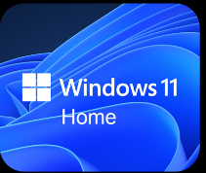 | 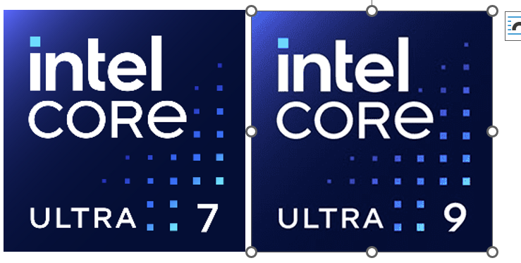 |  |  |  |  |  |  | 
Media Reviews – ENGLISH (ENG)
Publish to USA / CA
Section Headline |  | Media Reviews
Text Content
Image Selection |  | Generic | Generic |  | Generic |  | Generic
Reviewer Name
Quote (180)
Button & URL |  | Read More | Read More |  | Read More |  | Read More

Partner KSP 1
Image Reference
KSP Headline |  | PURE PERFORMANCE. PRECISION TUNED
KSP Body |  | A new class of gaming laptops built for split-second responsiveness, rock-solid FPS, and smart tuning that keeps you locked into the largest selection of games and apps. Powered by up to an Intel® Core™ Ultra 9 processor 290HX Plus.
Overline (20) |  |  |  | Up to Intel® |  |  | Up to |  | Up to
Spec (30) |  | Windows 11 Home |  | Core™ Ultra 9 |  |  | 24 Cores |  | 5.5 GHZ
Underline (20) |  | Operating System |  | processor 290HX Plus |  |  | 8P + 16E |  | Max Turbo Freq.
Partner KSP 2
Tech Headline |  | GAME CHANGER
KSP Headline (40) |  | GEFORCE RTX 50 SERIES LAPTOPS
KSP Body (250) |  | POWERED BY NVIDIA BLACKWELL AND AI
Overline (20) |  | Up to NVIDIA® |  |  | NVIDIA® |  |  | 5th Gen Tensor Cores
Spec (30) |  | GEFORCE RTX™ 5080 |  |  | ADVANCED OPTIMUS |  |  | MAX AI PERFORMANCE
Underline (20) |  | LAPTOP GPU (1334 AI TOPS) |  |  | Equipped |  |  | with FP4 & DLSS 4
Partner KSP 2.1
Image reference |  | 
Tech Headline |  | DLSS 4
Features Headline |  | SUPREME SPEED. SUPERIOR VISUALS. POWERED BY AI.
Features Body |  | DLSS is a revolutionary suite of neural rendering technologies that uses AI to boost FPS, reduce latency, and improve image quality. ‌The latest breakthrough, DLSS 4, brings new Multi Frame Generation and enhanced Ray Reconstruction and Super Resolution, powered by GeForce RTX™ 50 Series GPUs and fifth-generation Tensor Cores. DLSS on GeForce RTX is the best way to play, backed by an NVIDIA AI supercomputer in the cloud constantly improving your PC’s gaming capabilities.
Partner KSP 2.2
Image reference |  | 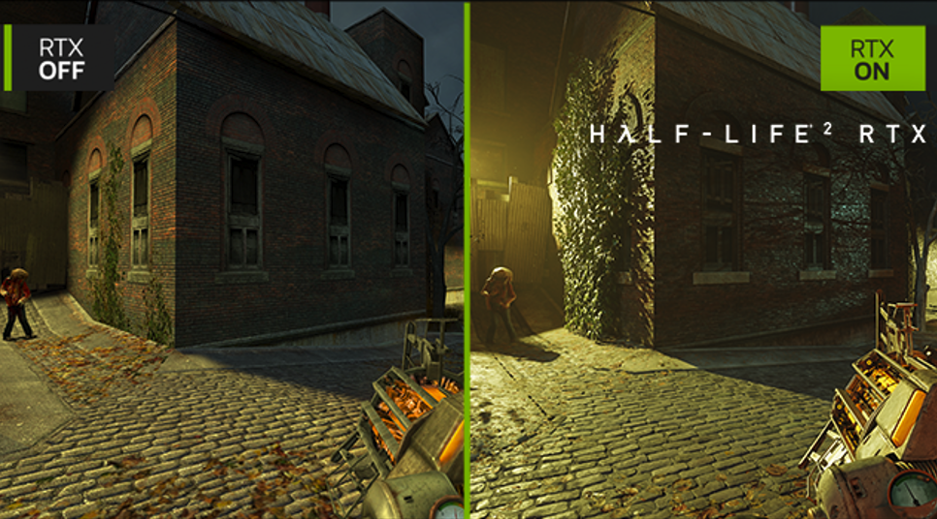
Tech Headline |  | FULL RAY TRACING WITH NEURAL RENDERING
Features Headline |  | GAME-CHANGING REALISM
Features Body |  | The NVIDIA Blackwell architecture unlocks the game-changing realism of full ray tracing. Experience cinematic quality visuals at unprecedented speed powered by GeForce RTX 50 Series with fourth-gen RT Cores and breakthrough neural rendering technologies accelerated with fifth-gen Tensor Cores.
Partner KSP 2.3
Image reference |  | 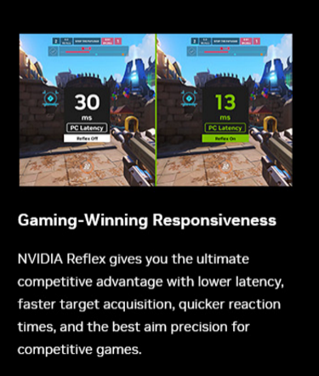
Tech Headline |  | NVIDIA REFLEX
Features Headline |  | GAME-WINNING RESPONSIVENESS
Features Body |  | NVIDIA Reflex gives you the ultimate competitive advantage with lower latency, faster target acquisition, quicker reaction times, and the best aim precision for competitive games.
Partner KSP 2.4
Image reference |  | 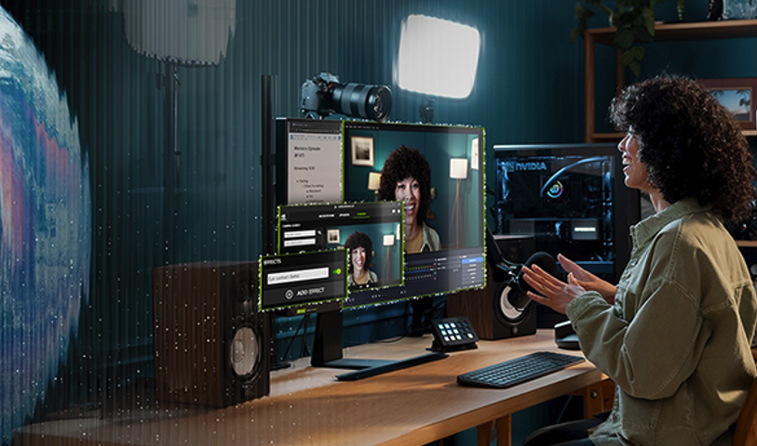
Tech Headline |  | RTX AI PC
Features Headline |  | NVIDIA POWERS THE WORLD’S AI. AND YOURS.
Features Body |  | Upgrade to advanced AI with NVIDIA GeForce RTX™ GPUs and accelerate your gaming, creating, productivity, and development. Thanks to built-in AI processors, you get world-leading AI technology powering your Windows PC.
Partner KSP 2.5
Image reference |  | 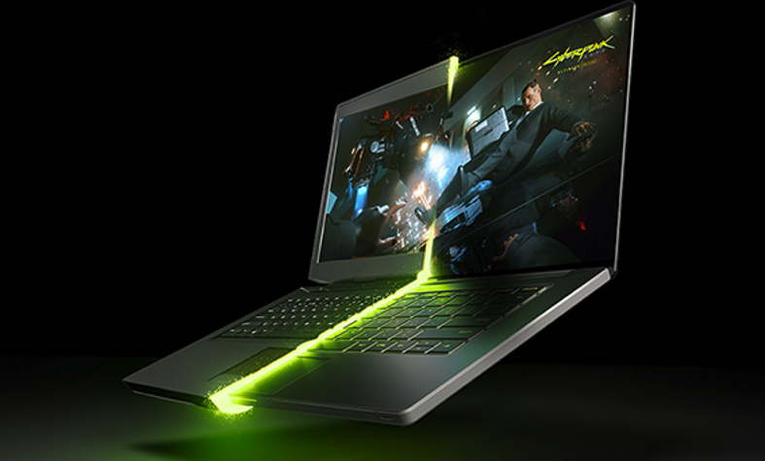
Tech Headline |  | NVIDIA BLACKWELL MAX-Q
Features Headline |  | OPTIMIZED POWER AND PERFORMANCE
Features Body |  | Max-Q is designed from the ground up for maximum efficiency, delivering a massive leap in performance and battery life.
KSP 1
Image reference |  | 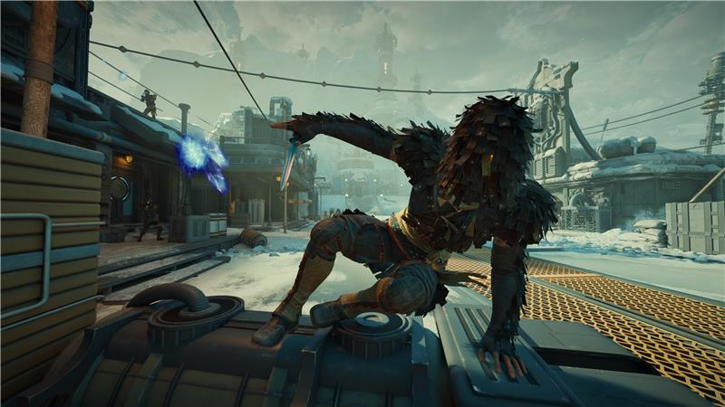
KSP Headline (40) |  | OLED PRECISION DISPLAY
KSP Body (220) |  | A 16-inch OLED WQXGA display with up to a 240Hz refresh rate, 1ms response time, and 100% DCI-P3 color delivers fast motion clarity, deep contrast, and precise visual control.
Overline (20) |  | Up to 16:10 | Up to |  |  | Up to |  |  |  | Up to
Spec (30) |  | OLED HDR | 240 Hz |  |  | 1MS |  |  |  | 100% DCI-P3
Underline (20) |  | 2560 X 1600 WQXGA | Refresh Rate |  |  | Response Time |  |  |  | Wide Color Gamut
KSP 2
KSP Headline (40) |  | ENGINEERED FOR THIN, AGILE PERFORMANCE
KSP Body (220) |  | At just ~18.9mm, this streamlined build carries serious firepower in a travel-ready form. Hardened for gamers who move between arenas, its thin profile delivers performance without the bulk, built to keep pace wherever the fight goes.
KSP 3
KSP Headline (40) |  | PRECISION THERMAL CONTROL
KSP Body (220) |  | A focused cooling system pairs 5th Gen AeroBlade 3D Fan Technology with liquid metal thermal grease to manage heat efficiently under load, helping sustain stable performance during extended gaming sessions and demanding multitasking.
KSP 4
Image reference |  | 
Logos (to be placed in main ksp graphic) |  | or   (choose one))
KSP Headline (40) |  | LOW-LATENCY GAMING WITH WI-FI 6E SPEED
KSP Body (220) |  | Intel® Killer™ Wi-Fi 6E, Killer™ DoubleShot Pro and Killer™ Ethernet E3100G deliver fast, low-latency links that hold steady under pressure, keeping your gameplay sharp, your comms clear and every competitive moment locked into real time.
Image reference |  | 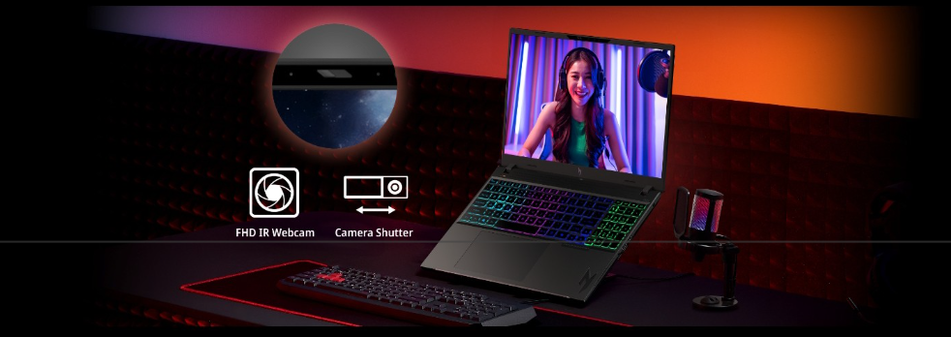  [needs to be predator themed]  Remove shutter
KSP Headline (40) |  | Sharper Focus
KSP Body (220) |  | The FHD IR camera delivers crisp, consistent image quality for streaming, squad coordination, and competitive play, keeping you visible and locked in when every call counts.
KSP 5
KSP Headline (40) |  | INSTANT CONTROL AT YOUR FINGERTIPS
KSP Body (220) |  | PredatorSense and Acer My Key sit on dedicated hotkeys for fast, frictionless control. Adjust cooling, lighting and system behavior instantly, keeping your focus locked on the fight without breaking momentum.
KSP 5.1
KSP Headline (40) |  | PREDATORSENSE
KSP Body (180) |  | Real-time command of fan curves, performance modes and system vitals, giving you tight, stable gameplay exactly when the pressure rises.
KSP 5.2
KSP Headline (40) |  | ACER MY KEY
KSP Body (180) |  | Assign instant shortcuts to tools, apps or system actions through a single press, cutting out delays and keeping your setup ready for anything.
KSP 6
KSP Headline (40) |  | ACER INTELLIGENCE SPACE
KSP Body (220) |  | Launch smarter performance through Acer Intelligence Space, your hub for AI-ready tools and hardware insights that fuel productivity, creativity, and gaming
CURRENT MS PARTNER KSP 7 (EOD 4/1/26)
KSP Headline (40) |  | DISCOVER YOUR NEXT FAVORITE GAME
KSP Body (220) |  | Play hundreds of PC games with your new Predator Windows 11 PC and three months of PC Game Pass, including EA Play. With new games added all the time, there’s always something new to play.
USE US or WW disclaimer – GO LIVE 4/1/26
NEW MS PARTNER KSP 7 (US)
KSP Headline |  | DISCOVER YOUR NEXT FAVORITE GAME WITH 2 MONTHS OF XBOX GAME PASS
KSP Body |  | Play Forza Horizon 5 and 200+ more games on your new Predator Windows 11 PC with 2 months of Xbox Game Pass Premium. New Xbox published games join the library within 1 year of launch. Dive into a range of legendary franchises from Call of Duty to Minecraft and everything in between. Get in-game benefits for the biggest games like League of Legends, Call of Duty: Warzone, Rainbow Six Siege, and more. Play and earn up to $50 a year in the Store with Rewards. Find your community with Xbox and play anywhere you want
NEW MS PARTNER KSP 7 (WW)
KSP Headline |  | DISCOVER YOUR NEXT FAVORITE GAME WITH 2 MONTHS OF XBOX GAME PASS
KSP Body |  | Play Forza Horizon 5, and 200+ more games on your Predator Windows 11 PC with 2 months of Xbox Game Pass Premium. New Xbox published games join the library within 1 year of launch. Explore a range of global franchises from Minecraft to Halo and everything in between. Get in-game benefits for the biggest games like League of Legends, Call of Duty: Warzone, and Rainbow Six Siege, and more. Play and earn up to 50,000 points per year with Rewards. Find your community with Xbox and play anywhere you want.
Disclaimers
 | This product is not designed for cryptocurrency mining uses. Damages to your product arising from cryptocurrency mining or related activities are excluded from your product’s warranty.
 | The terms HDMI and HDMI High-Definition Multimedia Interface and the HDMI Logo are trademarks or registered trademarks of HDMI Licensing Administrator, Inc. in the United States and other countries.
 | Specifications may vary depending on model and/or region. All models subject to availability.
Intel® technologies’ features and benefits depend on system configuration and may require enabled hardware, software, or service activation. Performance varies depending on system configuration. No product or component can be absolutely secure.

© Intel Corporation. Intel, the Intel logo, and other Intel marks are trademarks of Intel Corporation or its subsidiaries. Other names and brands may be claimed as the property of others.
 | The frequency of cores and core types varies by workload, power consumption, and other factors. Visit www.intel.com/technology/turboboost for more information.
 | Max Turbo Frequency is the maximum single-core frequency at which the processor is capable of operating using Intel® Turbo Boost Technology and, if present, Intel® Turbo Boost Max Technology 3.0 and Intel® Thermal Velocity Boost. Frequency is typically measured in gigahertz (GHz), or billion cycles per second.
 | Intel® Turbo Boost Max Technology 3.0 identifies the best performing core(s) on a processor and provides increased performance on those cores through increasing frequency as needed by taking advantage of power and thermal headroom. Intel® Turbo Boost Max Technology 3.0 frequency is the clock frequency of the CPU when running in this mode.
 | Maximum P-core turbo frequency derived from Intel® Turbo Boost Technology.
 | P refers to Performance-cores, E refers to Efficient-cores, and LPE refers to Low Power Efficient-cores
 | AI features may require software purchase, subscription or enablement by a software or platform provider, or may have specific configuration or compatibility requirements. Details at www.intel.com/aipc.
 | ©2026 NVIDIA Corporation. NVIDIA, the NVIDIA logo, GeForce, and GeForce RTX are registered trademarks and/or trademarks of NVIDIA Corporation in the United States and other countries. All other trademarks and copyrights are the property of their respective owners.
 | Depending on the region, this laptop may be bundled with a mouse. In such case, the mouse may not support NVIDIA Reflex functionality. Acer does not claim or guarantee compatibility of the bundled mouse with this feature.
 | Memory limits depend on the OS. For details on Windows 11 Home and other versions, visit Microsoft Learn: https://learn.microsoft.com/en-us/windows/win32/memory/memory-limits-fo+r-windows-releases.
 | Features and availability of Acer Intelligence Space (AIS) vary by model and region. Some functions require an active internet connection, supported hardware (such as an NPU or specific GPU), and future software updates. Performance may vary depending on system configuration
 | Only the top and bottom cover of the chassis are made with metal. Other parts of the device are constructed from plastic
 | PC Game Pass: Subscription continues automatically at regular monthly price unless cancelled. Subject to xbox.com/subscriptionterms. Terms and exclusions apply. Game catalog varies over time, by region, and by device. All rights reserved. xbox.com/pcgamepass, ea.com/ea-play/terms. (above disclaimer is from the FY25 Xbox marketing guideline for your reference)
New Disclaimer for Xbox GP. Go live 4/1/26
 | Claim within 30 days of device activation. New and eligible returning members only. Valid payment method required. Subscription continues automatically at regular monthly price unless cancelled. Subject to xbox.com/subscriptionterms. New Call of Duty titles will join the library at least 12 months after launch. Benefits vary by Xbox Game Pass plan. Game library varies over time, by region, device, and Xbox Game Pass plan. xbox.com/gamepass. In-game benefits vary by game, region, and over time. Game must be installed to access in-game benefits. Xbox Cloud Gaming requires an Xbox Game Pass subscription and supported device (both sold separately). Cloud playable games not included with Xbox Game Pass are sold separately, and may be made available with Xbox Game Pass in the future. See library: xbox.com/play. Stream directly on Xbox consoles, or with the Xbox app or at xbox.com/play on supported devices. Select regions (xbox.com/regions) and devices (xbox.com/cloud-devices). Rewards: Terms apply. Microsoft Account required. Select markets only. Rewards vary by Game Pass Plan and Rewards Level. Point values vary by local market currency, Rewards level, and the number of points redeemed. Point multipliers compared to Game Pass Essential earning potential. Gameplay rewards for 18+. Exclusive quests with Premium and Ultimate plans only, for titles in the Game Pass library. Qualifying purchases at Microsoft Store (online, or on Windows or console) at Rewards with Xbox.

